**Summary: A Study of Requirements Engineering Challenges in Large Distributed ERP Teams**

**Submitted By: Arbab Ashfaq Khan(21L-7420) & Nimra Arif(21L-7423)**

At **GSD**, software teams are distributed across the board in different places, and lots of problems arise due to social, cultural and physical factors and social and cultural barriers. Participants in distributed software teams include project managers, Project Coordinators, Needed Engineers / Businesses Analysts, Solution Builders, Developers, Quality Engineers etc. Demand of the engineering process is such an important thing and because of its recurring nature, avoiding RE processes is inevitable throughout the life cycle of the project.

The requirements are only requested, analyzed, negotiated, clarified, confirmed and managed if members of the software team have a certain level of skills, abilities and expertise as well can only be achieved by adopting good habits of team formation and management. This creates a need to explore the global RE challenges and their interactions with RE procedures and evaluate them on the basis of alternatives pointed to many recurring features namely; **Project costs, Project schedule, quality, customer satisfaction and team inspiration**.

It is really a challenge to develop effective software teams. If these cross-border groups are not well managed it can have negative effects on lead projects, great loss of business, economy and even human life, it can be dangerous in the event of significant health projects. So the real motivating factors behind this research work are to point out some useful guidelines that are useful to increase the chances of being on time and successfully delivering software projects. With successful projects, we mean a quality product that has all the projects participants encouraged and satisfied including software teams, users and customers. End user diversity requirements for in-depth participants project involvement are important. The study has identified our own research problem followed by research questions.

**Problem Statement**: Study and Analysis of RE identified challenges of distributed groups and self-assessment of selected study items namely; Project Costs, Project Schedule, Software Quality, Customer Satisfaction and Team Motivation based on large scale distributed team project implementation research and feedback from industry personnel from various parts of the world. **RQ1**: What aspects of project evaluation related to the required engineering challenges and team structure and management in distributed software teams? **RQ2:** Are the identified diagnostic features important to industry workers? **RQ3**: We can use the project evaluation features identified in a distributed located project to measure the effectiveness of a distributed team based on a specific metrics **RQ4**: Is there a specific RE practice that is very important w.r.t. team formation and management.

**Methodology:** Our research is based on the following two strategies:

**Industrial Survey:** A survey aimed at recruiting and evaluating employees feedback on research topics was conducted. Responses are accepted from different regions against the nomination.

Data is collected using a google based online survey. The purpose of establishing a questionnaire is to obtain information on it from industry experts. The questionnaire consists of 32 questions in total covering large areas of our research problems.

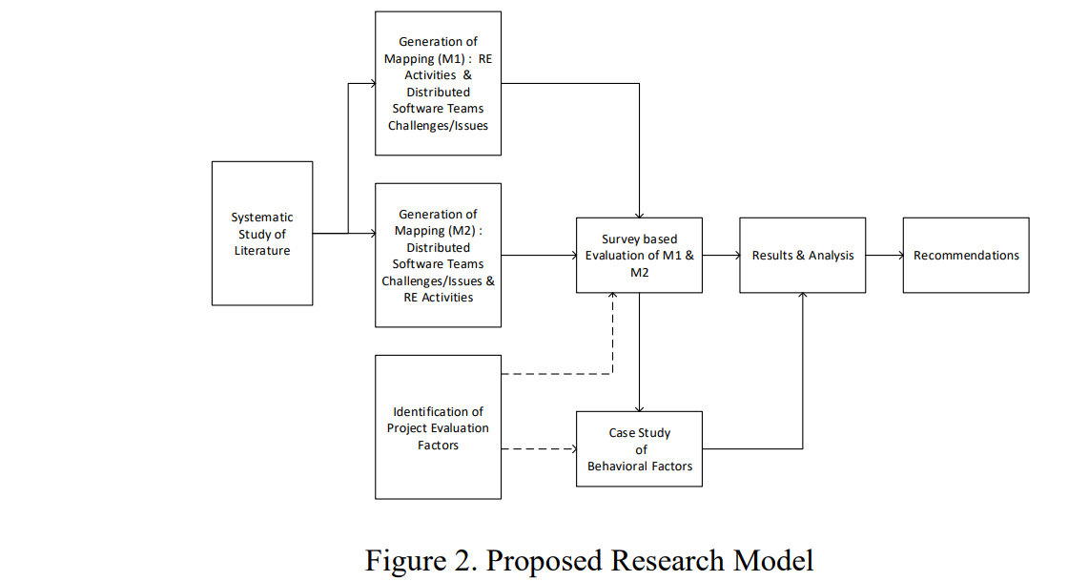

We also used similar methods in collecting our research data

1) Direct (Negotiations)

2) Indirect (Observation)

3) Private (Document Analysis - Database)

**Evaluation Factors**

1. **Project Cost**: Project costs are strongly associated with the RE process, as it is a well-known fact that if the RE process is not done properly and missed requirements are passed to the next stages of the Software development life cycle and remain anonymous in the final product release, then one can imagine how much it will affect the cost of the project. If the RE process is well run then the team can deliver the product one week before the scheduled schedule.
2. **Project Schedule**: If the RE’s global challenges are not properly addressed, it has an impact on the project plan and ultimately results in late project delivery. On the contrary, if the RE process is successfully run then the team can deliver the product one week before the scheduled schedule, in compliance with 20 percent.
3. **Software Quality**: Quality is compliance with Customer Requirements because all the Requirements should meet the standard Quality Requirements. The quality product proves that all RE processes are independently focused and performed by high quality distributed teams.
4. **Customer Satisfaction**: A timely quality product is a key requirement for a happy customer and especially the result of the required engineering process. Delayed releases mainly due to incomplete RE operations performed by non-professional broadcasters.
5. **Team Motivation:** Work satisfaction is a normal attitude of work that is displayed by employees in the workplace. Performance is based on job satisfaction governed by a variable called “Reward”.

**Case Study**: This case study is based on distributed implementation of projects with various distributed team’s groups on different sites. Projects based in Pakistan and teams are from Pakistan and USA. Results along with research results just to analyze the similarity of the gap among the international response physicians / respondents and research findings fully recommends the RE Based Model on final analysis of both the questionnaire and the subject lesson results we will try to reach the same required point for global construction and management distribution teams that will help us to define what RE practice requires more concentration to be more successfully. The distributed implementation of the project rolled out more than 04 locations involving distributed groups within Pakistan and USA taking charge of this project according to their specific role.

It is clear from this research work that there are more challenges and issues related to human behavior than technical issues that make the RE process less effective. It is clear from the results and analysis of both the survey and case studies that RE activities are considered very important and the process is somehow uncertain if done incorrectly. We have learned from our literature research that there are various methods and tools available to software companies to address the global RE-identified challenges but the RE process is still suffering. Our result of the questionnaire showed the almost equal weight of group motivation needed for further consideration and Reward (Intrinsic, Extrinsic) is considered the main source of team motivation. In the study, it was also analyzed on other bases that by dealing with the internal rewards of a software team whether distributed or a team in a single location, team motivation was increased. This study focused on the importance of RE processes. Based on the research questions mentioned, this study identified a) RE challenges and project evaluation factors from the literature (such as project schedule. Project costs, software quality according to customer satisfaction) b) RE challenges related to standard RE procedures c) Evaluated the importance of project evaluation materials using an industrial survey d) Evaluate the mapping between RE challenges and general RE processes e) Conduct a sample study of distributed projects by implementing identified project evaluation features. After studying the effects of distributed team challenges in the RE process in case studies, it is recognized that **behavioral challenges** are more weighty compared to technical challenges.

The case study investigates the impact of internal remuneration on project evaluation and team motivation. The award has a positive impact on aspects of project evaluation and enhances team motivation. Variations in the project schedule, cost variations and customer satisfaction improved by **29 percent, 25 percent and 29 percent** respectively. The quality of interaction between team members has improved after group training, which shows improvement in team motivation.

Attitude, which is an important part of emotional intelligence, helps to increase team productivity and handle RE challenges. In the workplace, the perception of work events during the entire working day affects the employee’s attitude and thus has an impact on the employee’s performance. Further research should be done to investigate the impact of attitudes on project assessment items.